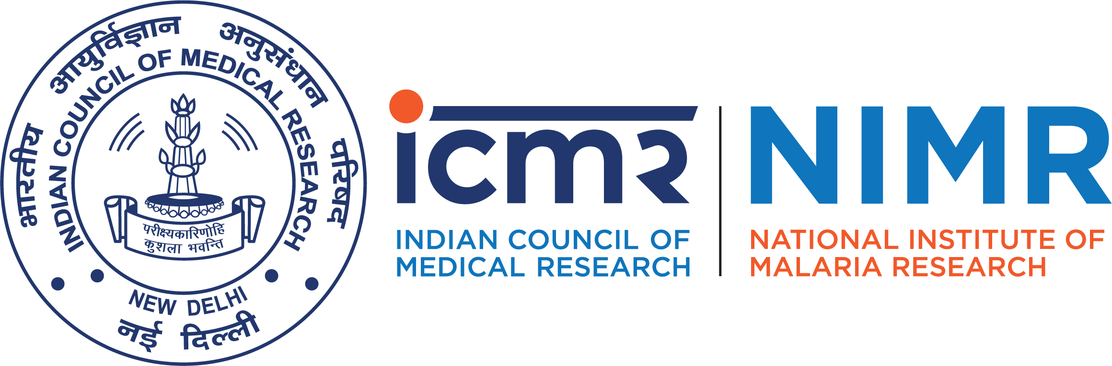

ICMR- national institute of malaria research
Indian Council of Medical Research (department of health research)
sector-8, dwarka, new Delhi- 110077, India
Tel:+91-11-25307103, 25307104, 25361092, 25361093
website : www.nimr.org.in

Applications are invited in advance through email (coordinatormera@gmail.com) upto 12.05.2020 upto 05:00 p.m.in the prescribed format (available on website www.nimr.org.in) alongwith requisite documents for appearing in the walk-in-interview/personal discussion as per schedule for the following purely temporary project posts, tenable at ICMR-NIMR for the period mentioned below. The term may be extended further as per requirement. Candidates possessing required qualifications, experience and age criteria may attend the walk-in-interview/personal discussion through Skype/video call at ICMR-NIMR, Sector-8, Dwarka, New Delhi -110077 on the date as indicated in schedule for walk-in-interview/personal discussion along with the filled in application form and supporting documents in support of their date of birth, qualifications and experience. Other terms and conditions and date & time of walk-in-interview/personal discussion are also given here under:

I | Project: Malaria Elimination Research Alliance – India (PI: Dr. Anup Anvikar) – Duration up to 30.09.2020.
Sl.No. | Name of Post |  | Monthly Consolidated Emolument |  | Essential Qualifications/ Desirable qualification and experience |  |  | Age limit
1. | Scientist-D (Non Medical) |  | Rs. 54000/- pm plus HRA as applicable |  | 1st class master degree with relevant subject from a recognized university with eight years experience or 2nd class MSc/PhD Degree in relevant subjects from recognized university with eight years experience  Desirable: Candidate should have strong scientific writing and verbal skills. |  |  | 45 years
2. | Project Officer 01 post (UR) |  | Rs.32,000/- pm |  | Graduate in any discipline from recognized university with five year work experience of administration/ finance and accounts work.  Desirable: Bachelor degree in Commerce from recognized university/ institution. Knowledge of computer applications. |  |  | 30 years

3. | Data Entry Operator Grade – A 01 post (UR) | Rs.17,000/ pm | Intermediate or 12th Pass from recognized board with a speed test of not less than 8000 key depressions (in English) per hour through speed test on computer. | 25 years

Terms and Conditions:

1. Interested and eligible candidates can appear for walk-in-interview/personal discussions on the dates mentioned against each post alongwith the duly filled in the prescribed application form (attached).
2. It may be mentioned here that incomplete applications, application not submitted in prescribed format and application without supportive documents asked for shall be summarily rejected.
3. Qualification and experience should be in relevant discipline/field and from a reputed institution / organization recognized by relevant authority.
4. Experience shall count from the date of completion of minimum educational qualification.
5. Submission of incorrect or false information during the process of walk-in- interview/or personal discussion shall disqualify the candidature at any stage.
6. The Director reserves the right to increase / decrease the number of vacancies as per requirement.
7. Candidate should write the Name of Project on the top of the application. Candidates applying for more than one post should apply SEPARATELY for each post.
8. No benefit of provident fund, Leave Travel Concession, Medical Claim etc. will be considered, since the posts are purely temporary basis.
9. Age relaxation is admissible to SC/ST/OBC/EXM/Departmental candidates including projects as per Govt. of India/ICMR Norms.
10. Age limit and experience will be considered as on the date of walk-in-interview/personal discussion.
11. No TA/DA will be paid for attending the walk-in-interview/personal discussion.
12. Mere fulfilling the essential qualification / experience does not guarantee selection.
13. Candidates employed in Govt. Service /Semi Govt./ Autonomous Bodies of State/Central Govt. should submit a “No Objection Certificate” from their employer at the time of walk-in- written test and / personal discussion failing which he/she will not be allowed to appear in written/personal discussion.
14. If the eligible candidates are more than 30, then written test will be held followed by personal discussion otherwise direct personal discussion will be held from the time of written test as indicated onwards. Written test will be consisting of objective and multiple type questions on syllabus as per the essential qualification.
15. Community/ Caste certificate: Candidates applying under OBC category, shall submit attested copy of OBC Non – Creamy Layer Certificate in specified format, issued within one year from the date of walk-in- written test and / or personal discussion by the appropriate authority. Only Non Creamy Layer OBC certificates will be accepted and other certificates will not be accepted.
16. All posts are contractual for the duration offered. The appointment may be renewed after every specific period of time subject to satisfactory performance and project requirement.
17. The above posts are filled-up on purely temporary basis and contractual basis & the candidate will have no right to claim for any type of Permanent Employment under ICMR-NIMR or continuation of his/her services in any other project.
18. The Director has the right to accept/reject any application without assigning any reason thereof and no correspondence/recommendation will be entertained in this matter.
19. Canvassing and bringing outside influence in any form for short listing and employment will treated as disqualification and the candidate will be debarred from selection process.

20. Candidates are advised to send their application form alongwith requisite documents in advance through e-mail (coordinatormera@gmail.com) upto 12.05.2020 05:00pm. Candidates possessing the above essential qualification and experience may appear for walk-in- interview/or personal discussion (Through Skype/video call) at Director, ICMR-National Institute of Malaria Research, Sector-8, Dwarka, New Delhi-110077 on the dates as indicated in schedule for walk-in- interview/or personal discussion (as applicable) given below:

SCHEDULE FOR WALK-IN- INTERVIEW/PERSONAL DISCUSSION

Sl. No. | Post | Date and time of verification of document
1. | Scientist-D (Non Medical) | 13.05.2020  from 10:00 am to 12:00 noon
2. | Project Officer | 13.05.2020  from 12:00 noon to 02:00pm
3. | Data Entry Operator | 13.05.2020  from 03:00 pm to 04:00 p.m.

21. Those appearing for walk - in – Interview/personal discussion, in case of selection, he/she must bring all original certificates (1) Educational qualification (2) Proof of Date of birth (3) Experience certificates/testimonials (4) One-self attested recent passport size photograph (5) ID Proof (Ex. Aadhar/PAN/Voter ID/Driving License etc.) (6) One set of self-attested photocopies of all documents. (7) SC/ST/OBC Certificates, if applicable. (8) Candidates should produce all certifications/testimonials in original for verification at the time of joining the post.
22. Candidates who fail to bring the original certificates at the time of joining, he/she will not be allowed to join the selected post. Candidates who will report after the scheduled date/time will not be allowed to appear in interview / or personal discussion.
23. Bad connection/connection failure from any side will be the responsibility of the NIMR.
24 Speed test on computer in English only will be conducted as qualifying criteria for Data Entry Operator after verification of essential qualification and experience at the time of joining. In case, if it is not found satisfactory, appointment will be terminated.
25. Any Addendum/Corrigendum in respect of above vacancy notice shall be issued on websites www.nimr.org.in only and no separate notification shall be issued in the press. Applicants are requested to regularly visit the website (www.nimr.org.in) to keep themselves updated.

Further for more information on ICMR-NIMR can be viewed on the website (www.nimr.org.in).

Posted on Website of ICMR- NIMR / ICMR on 28th April 2020.

