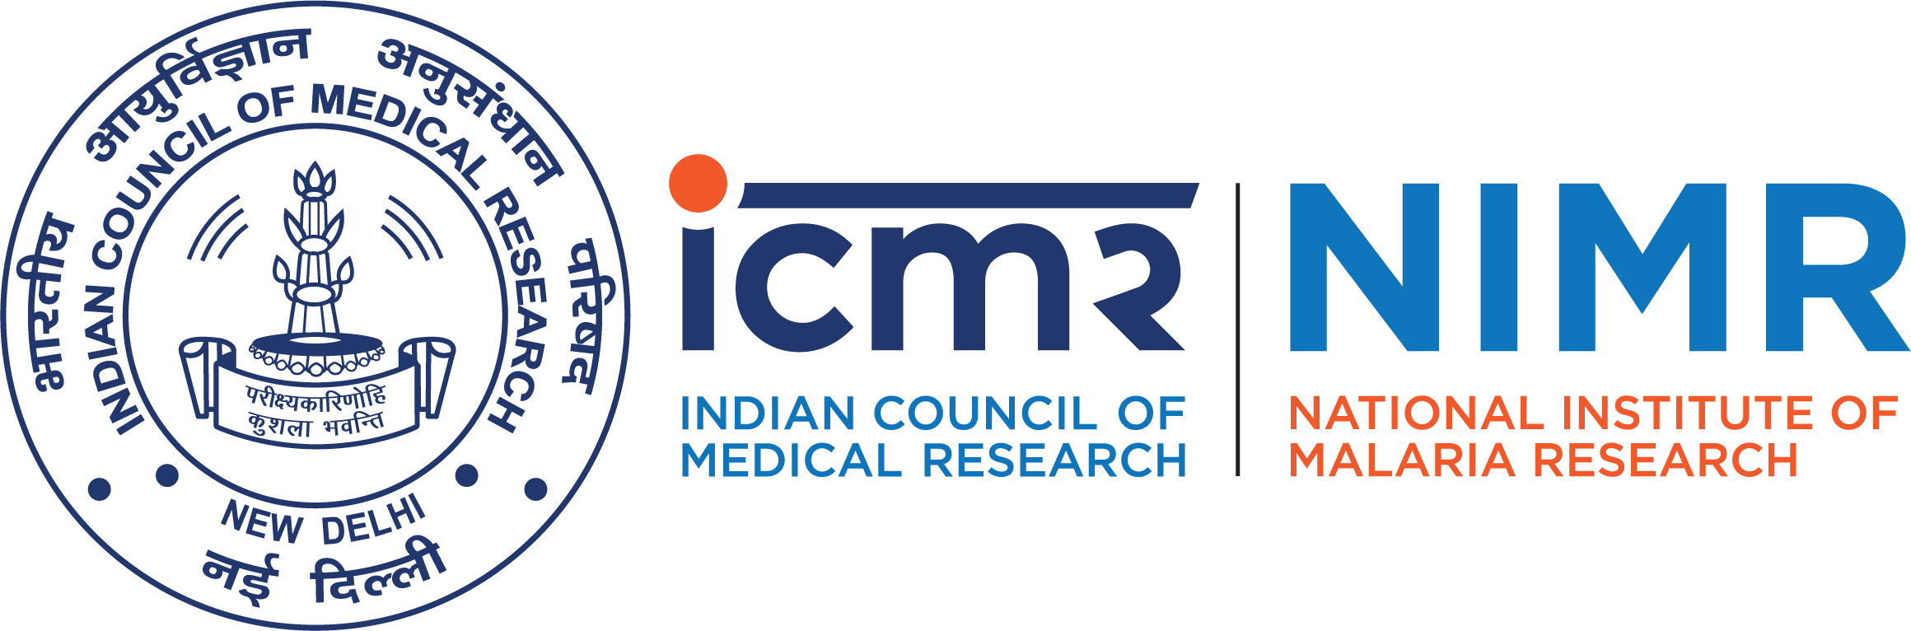
ICMR–National Institute of Malaria Research
(Indian Council of Medical Research)
Sector-8, Dwarka, New Delhi–110077

Advt.No. NIMR/Admn/P&I/646/2013 Date: 27/08/2019
Vacancy notification

Applications are invited for engagement of a full time Consultant (Publication) (Scientific/Technical–Non-Medical) purely on contractual basis, for a period of one year (extendable as per suitability and requirement) in the Publication Division of ICMR–National Institute of Malaria Research, New Delhi. Essential details are mentioned below:
Name of the Post: Consultant (Publication) (Scientific/Technical–Non-Medical)

Essential Criteria:

- Professionals should have Master’s Degree in Life sciences, and
- Documented knowledge of vector borne diseases, print-production and editing/processing of scientific journals; with published papers.
OR
Retired Govt. employees with Grade Pay of `4600/- and above and having at least 20 years’ experience in the required domain/field as mentioned in point 2 above.
Desirable Criteria:

- Two years’ experience in editing and processing of scientific journals/publications.
- Diploma or other professional certification in publishing/print-production/writing.
- Good command over English language; knowledge ofpeer-review system, print and production, computer and Adobe applications.
Work Responsibilities:

Screening and assignment of manuscripts, editing of accepted manuscripts to be published in the Journal of Vector Borne Diseases, copyediting, compilation and editing of annual reports plus other publications of the Institute and other related works assigned as per the requirements.

Consolidated Remuneration: `25,000 – 1, 00,000/- per month depending upon the educational qualifications, relevant experience, last pay drawn and functional requirements.

Age Limit: Below 70 years as on 11/10/2019.
Application procedure: The interested candidates/professionals may apply in the prescribed format (Annexure I) and send their application along with the self-attested copies of educational qualifications, certificates, experience, and Curriculum Vitae to the Director, ICMR–National Institute of Malaria Research, Sector-8, Dwarka, New Delhi–110 077. Envelope should be super-scribed with Post Name. Only the shortlisted candidates will be called for Interview and will be informed through email/phone accordingly. The last date of receiving the applications is 11/10/2019.
Administrative Officer

Annexure – I
ICMR–National Institute of Malaria Research
(Indian Council of Medical Research)
Sector-8, Dwarka, New Delhi–110 077

Last date: 11/10/2019
Application Form for the post of Consultant (Publication)

Paste
recent colour
Passport size
photograph
1. Full Name (in capital) : ………………………………………………………………………………
2. Father’s/Husband’s name : ………………………………………………………………………………
3. Date of birth : ………………………………………………………………………………
4. Age as on 11/10/2019 : ………………………Y……………………M………………………D
5. Nationality : ………………………………………………………………………………
6. Address for correspondence : ……………………………………………………………………………………………………………………………
……………………………………………………………………………………………………………………………
……………………………………………………………………………………………………………………………
……………………………………………………………………………………………………………………………
........................................ PIN……………..............…….…………………………
E‐mail : ………………………………………………………………………………………..………………………………….
Phone/Mobile No. : ……………………………………………..……… ………………………………………………………
7. Permanent address : ……………………………………………………………………………………………………………………………
……………………………………………………………………………………………………………………………
……………………………………………………………………………………………………………………………
……………………………………………………………………………………………………………………………
PIN..............................Phone/Mobile No. :……………..............………………….

1

8. Educational/Professional qualifications Annexure – I
S.  No. | Examination  Passed  (Mention Specialization) | University  or Board | Subjects | Year of  passing | %age | Division/Grade
1. | High School
2. | Intermediate
3. | B.Sc.
4. | M.Sc.
5. | Ph.D.
6. | Any other

9. Details of previous/present employment
S.  No. | Name of the post held | Employer/  Organization | Pay scale/  Salary/Pension | Period | Nature of  duties
1.
2.
3.
4.
10. Any other relevant information such as desirable experiences, research papers published, computer skills, training courses attended, etc.(Use separate sheets if necessary).

11. Techniques known (related to print and production):

Declaration
It is certified that the information provided in this application is true and complete in all respect to the best of my knowledge and belief. If anything is found wrong/incorrect, my candidature can be summarily rejected or cancelled.

Signature of the candidate
2
Place:
Date:

